1. **Problem 1:**
   1. Suppose we collect data for a group of students in a statistics class with variables X1 = hours studied, X2 =undergrad GPA, and Y = receive an A. We fit a logistic regression and produce estimated coefficients.

**βˆ0 = −6, βˆ1 = 0.05, βˆ2 = 1.**

* 1. (a) Estimate the probability that a student who studies for 40 h and has an undergrad GPA of 3.5 gets an A in the class.
     1. 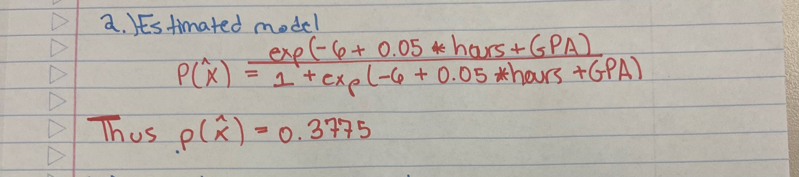
  2. (b) How many hours would the student in part (a) need to study to have a 50% chance of getting an A in the class?
     1. 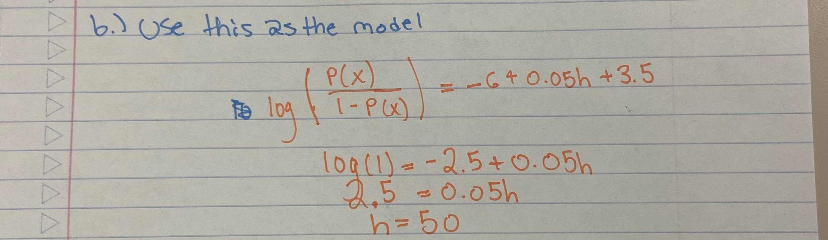

1. **Problem 2:**In this problem, you will develop a model to predict whether a given car gets high or low gas mileage based on the Auto data set in the ISLR package.
   1. Create a binary variable, **mpg01**, that contains a 1 if mpg contains a value above its median, and a 0 if mpg contains a value below its median. You can compute the median using the **median()** function. Note you may find it helpful to use the **data.frame()** function to create a single data set containing both **mpg01** and the other Auto variables.
   2. Explore the data graphically in order to investigate the association between **mpg01** and the other features. Which of the other features seem most likely to be useful in predicting **mpg01**? Scatter Plots and box plots may be useful tools to answer this question. Describe your findings.
   3. Split the data into a training set and a test set.
   4. Perform logistic regression on the training data in order to predict mpg01 using the variables that seemed most associated with **mpg01** in (b). What is the test error of the model obtained? That is use the test data to predict and get the confusion matrix and determine the error rate.
2. **Problem 3:**
   1. Write a function, Power(), that prints out the result of raising 2 to the 3rd power. In other words, your function should compute 2^3 and print out the results.
      1. Hint: Recall that x^a raises x to the power a. Use the print() function to output the result.
      2. **Answer: 8**
   2. Create a new function, Power2(), that allows you to pass any two numbers, x and a, and prints out the value of x^a.You can do this by beginning your function with the line
      1. **Answer: 6561**
   3. Using the Power2() function that you just wrote, compute 10^3, 8^17, and 131^3
      1. **Answer: 1000, 2.251e+15, 2248091,**
   4. Now create a new function, Power3(), that actually returns the result x^a as an R object, rather than simply printing it to the screen. That is, if you store the value x^a in an object called result within your function, then you can simply return() this result, using the following line:
   5. Now using the Power3() function, create a plot of f(x) = x^2.The x-axis should display a range of integers from 1 to 10, and the y-axis should display x^2.Label the axes appropriately, and use an appropriate title for the figure.
      1. 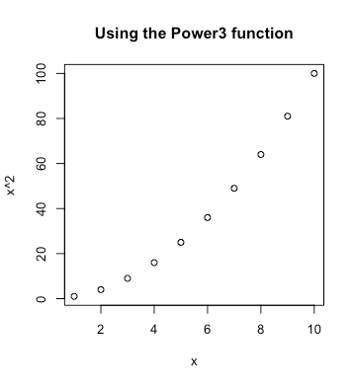
   6. Create a function, PlotPower(), that allows you to create a plot of x against x^a for a fixed a and for a range of values of x. For instance, if you call
      1. 